Instruction to convert foreign currency and make payments to Sri Lanka

*Through mobile application*

1. You need to download the application **Natsinvestprombank** (in Russian - **Нацинвестпромбанк**) in Google Play or App Store. If the main language of your mobile phone is English, the application will have English interface.

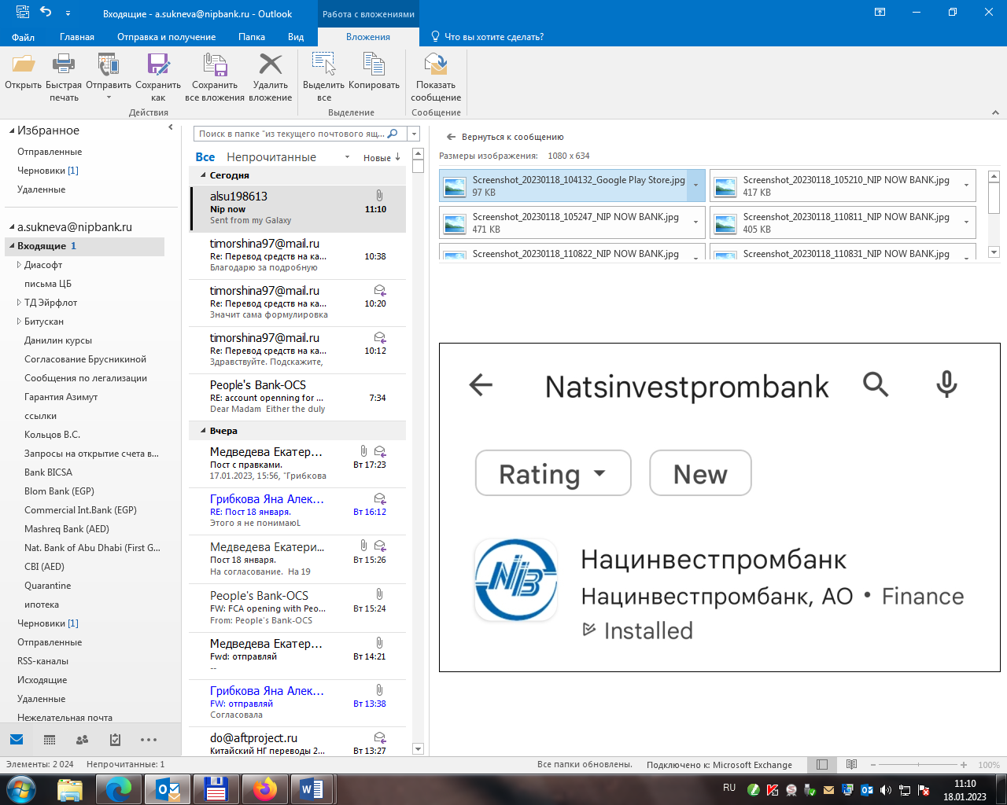

1. An SMS from NIPBank will be sent to the number specified during registration (Russian phone number) with one-time password for the initial login to the Internet Banking system.

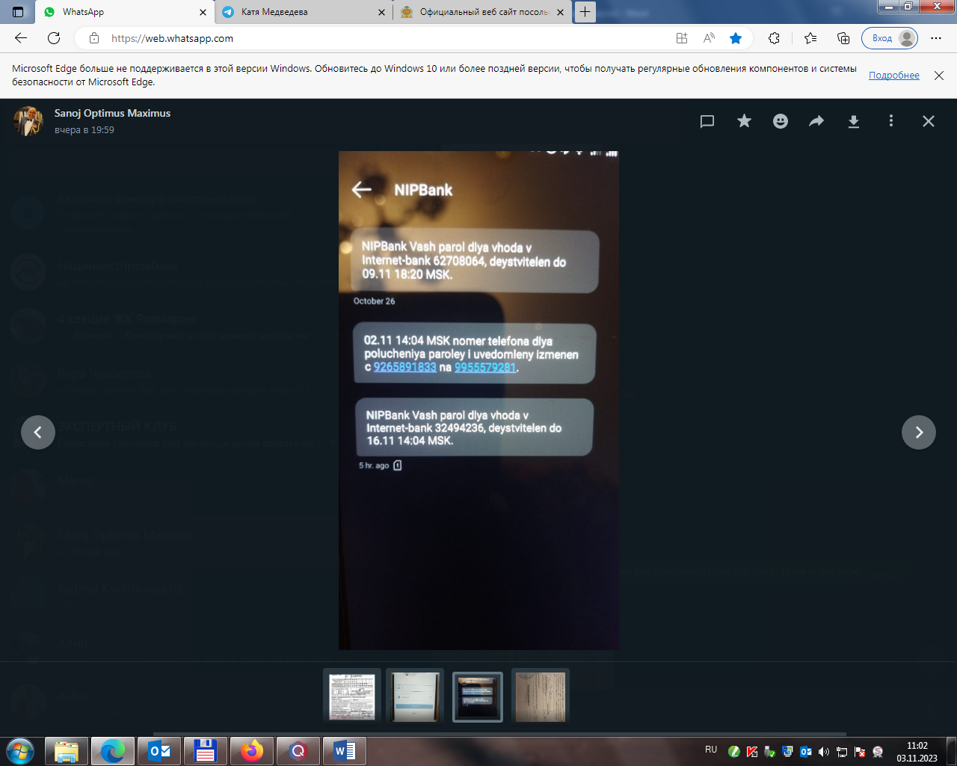



It means: NIPBank your password to log in the internet-bank 32494236 (as example), is valid until 16.11.2023 14:04 MSK time.

1. At the initial registration to the bank's application, use your login specified in the application for internet-bank system: **nip_** and the **password from the SMS message**. Next, press **LOG IN** button.

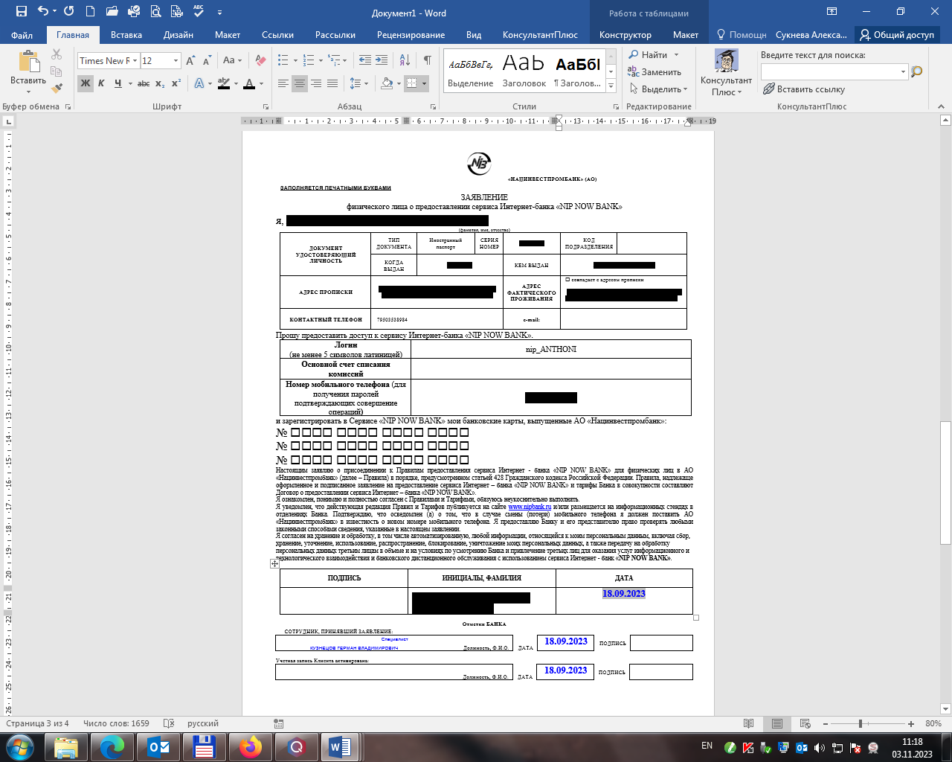

login

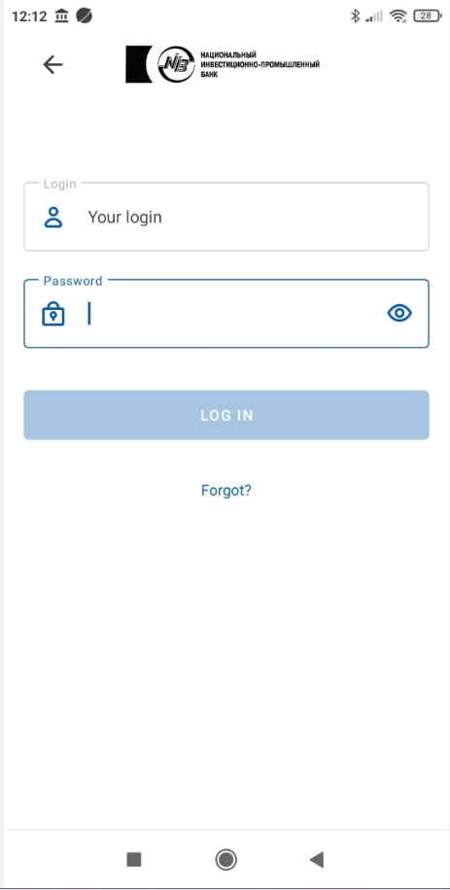

nip_ANTHONI

1. You will be offered to set the constant password. For this, indicate your old password (one-time password from the SMS), then new password which should be more than 8 symbols, contain one capital letter, one digit, one symbol (-, !, % ). Then input the new password one more time. Press CONFIRM button.
2. You will receive SMS with the confirmation code to change the password.
3. After that, you will be offered to set 4 digits to enter the app without login and constant password.

**FOREIGN CURRENCY EXCHANGE**

1. To make currency exchange from RUB to USD, select the **Payment** tab on the main page

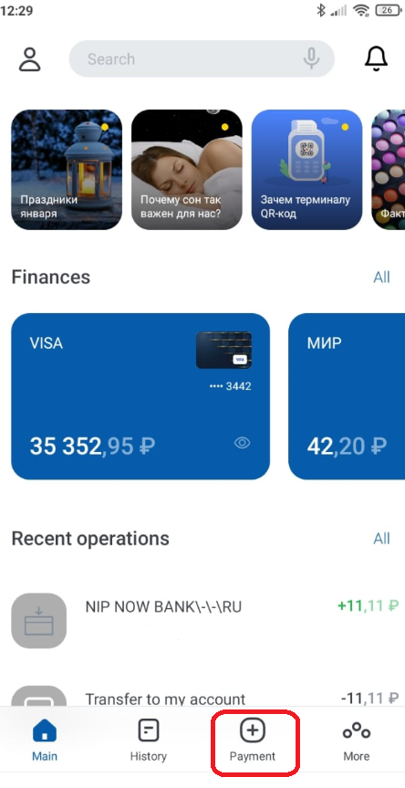

1. Next, select **Currency exchange**

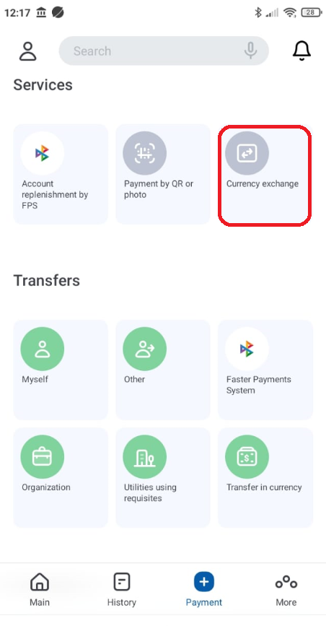

1. Select an account for debiting (ruble) and crediting (in USD), specify the amount in Rubles or US Dollars. Click TRANSFER. The exchange rate is published each day anew and is indicated in the app.

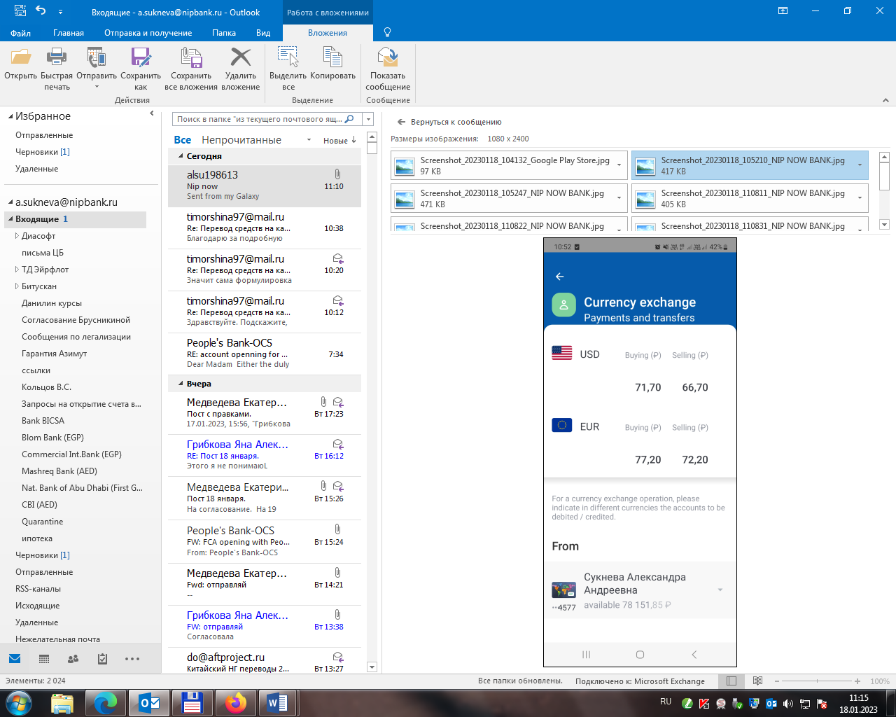

Available 50 000,00 P

Account holder’s name

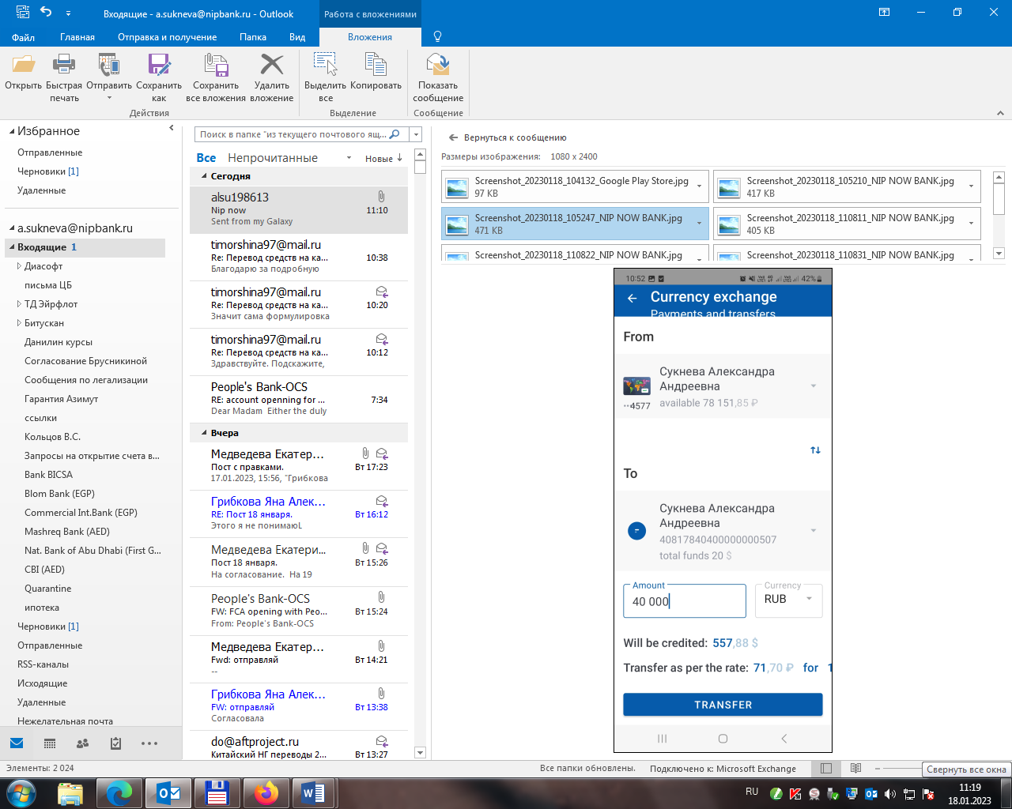

Account number in USD:

40820840____________

Account holder’s name

1. You will receive SMS with the confirmation code to make the exchange transaction.

**TRANSFER IN USD TO SRI LANKA**

1. To send a payment to Sri Lanka, select **Payment** tab, then **Transfer in currency**.

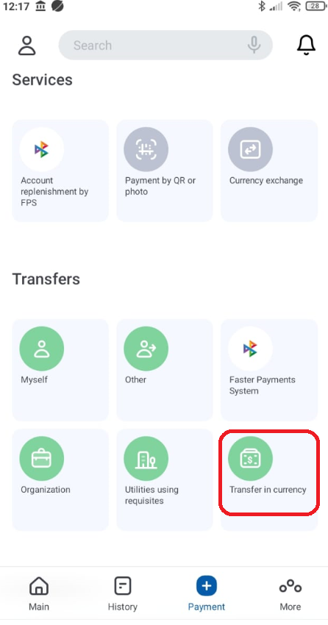

1. Fill in the details for the transfer.

SAMPLE is BELOW:

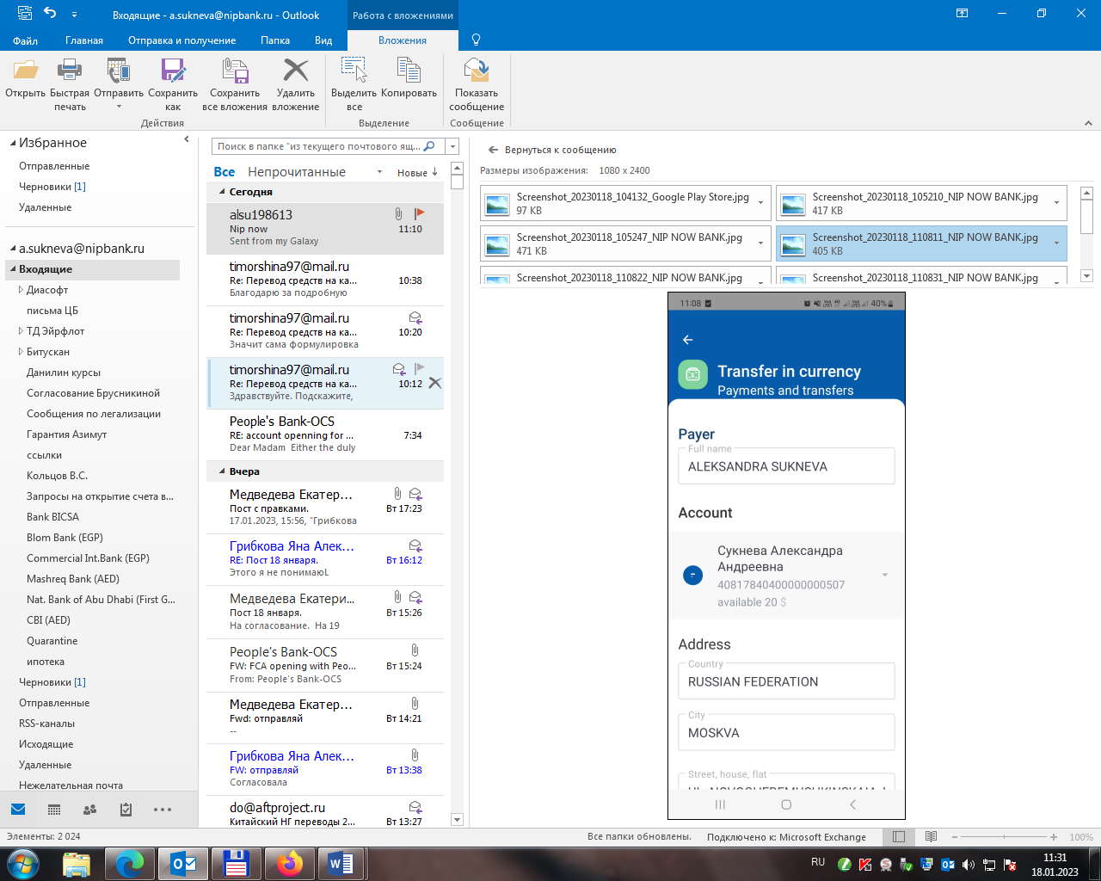

Kromy District, Kromy village, Sidelnikova lane, 19, of. 26

OREL

IVAN IVANOV

Account number in USD:

40820840____________

Available $

IVAN IVANOV

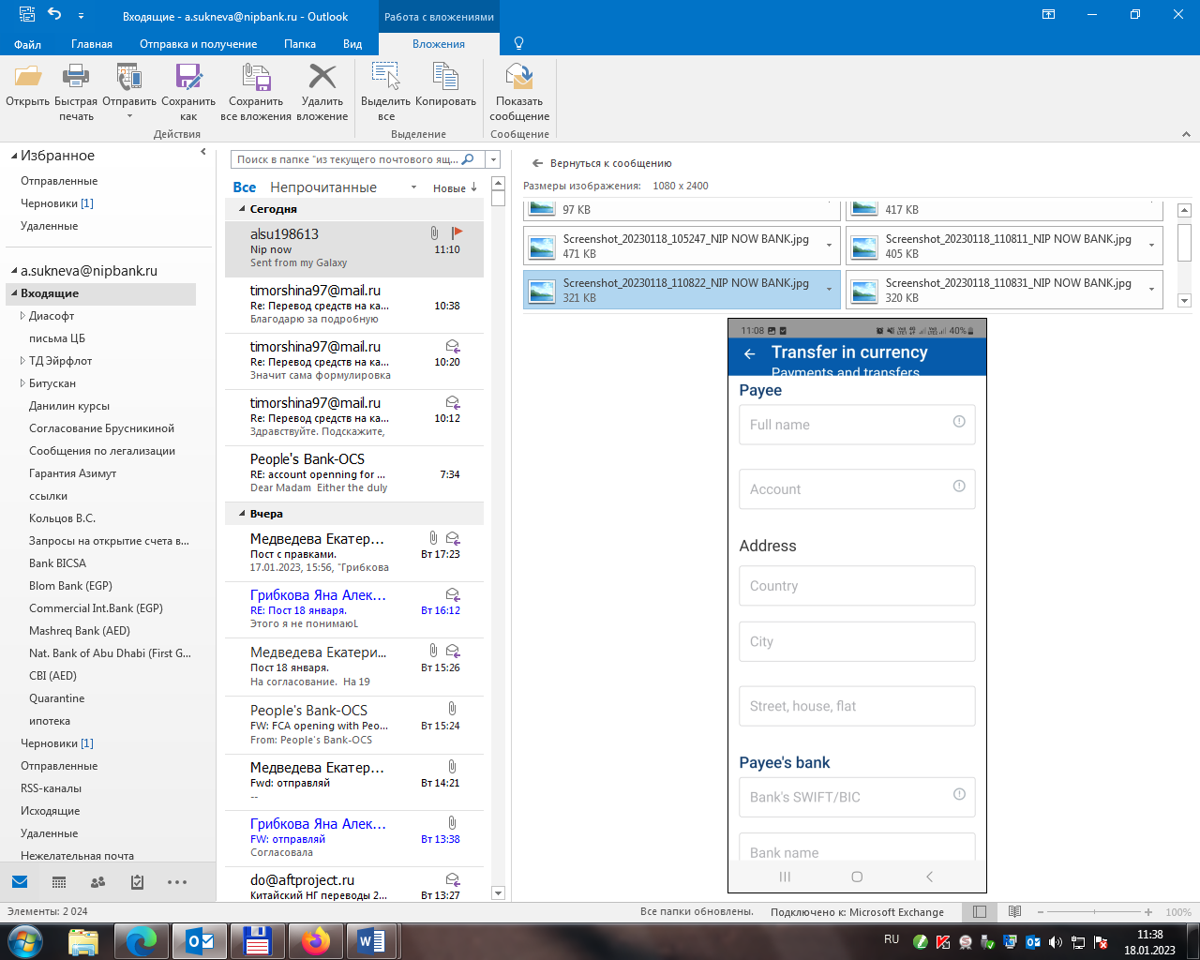

SRI LANKA

PEOPLE'S BANK, HEAD OFFICE, HEAD OFFICE

PSBKLKLX

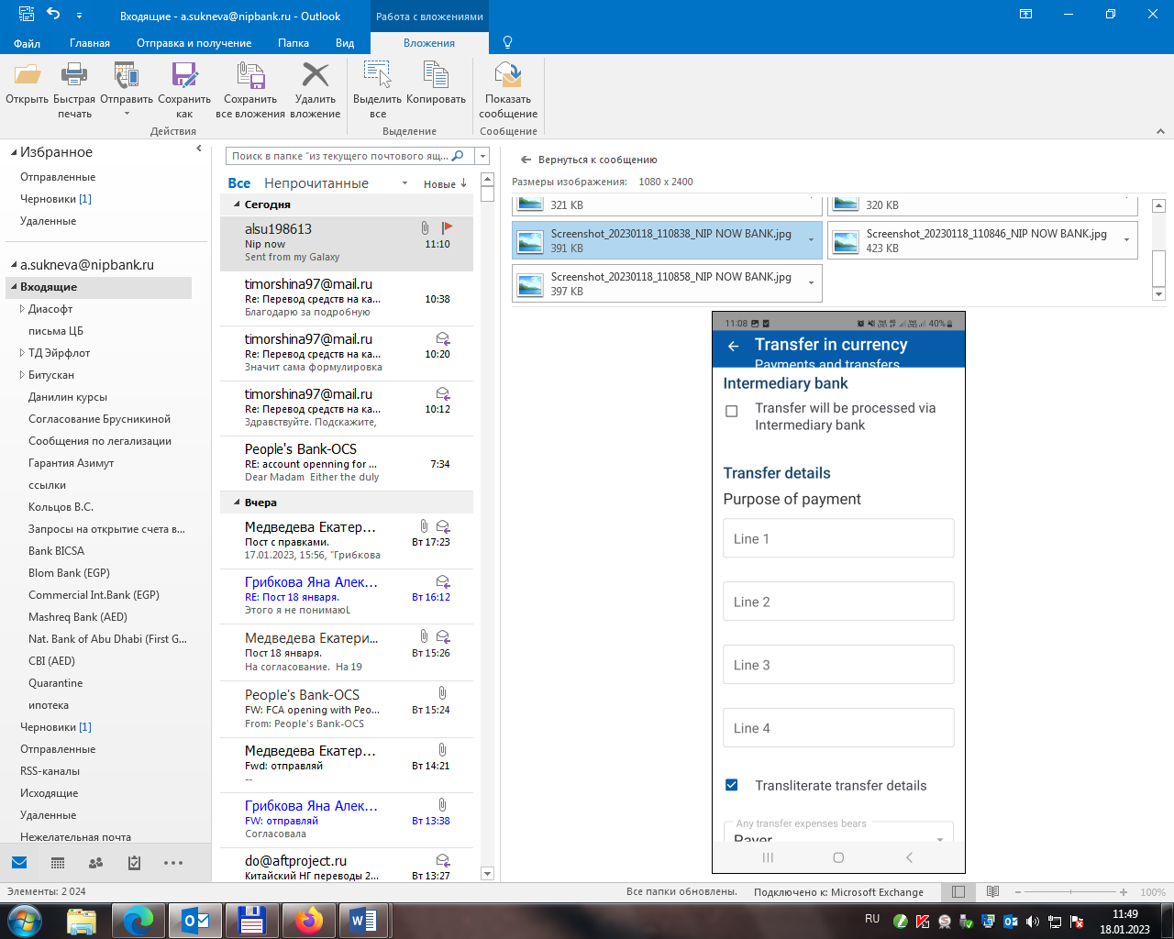

not filled in

not filled in

not filled in

TRANSFER OF OWN FUNDS

not filled in

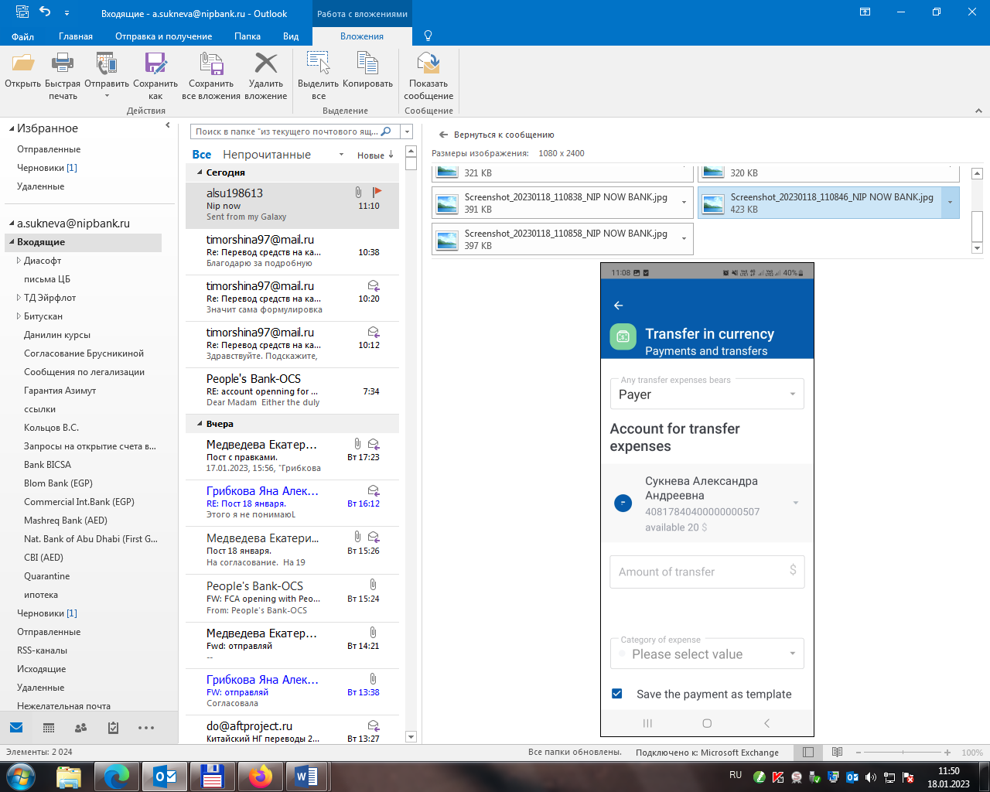

not filled in

Account number in USD:

40820840____________

Available $

IVAN IVANOV

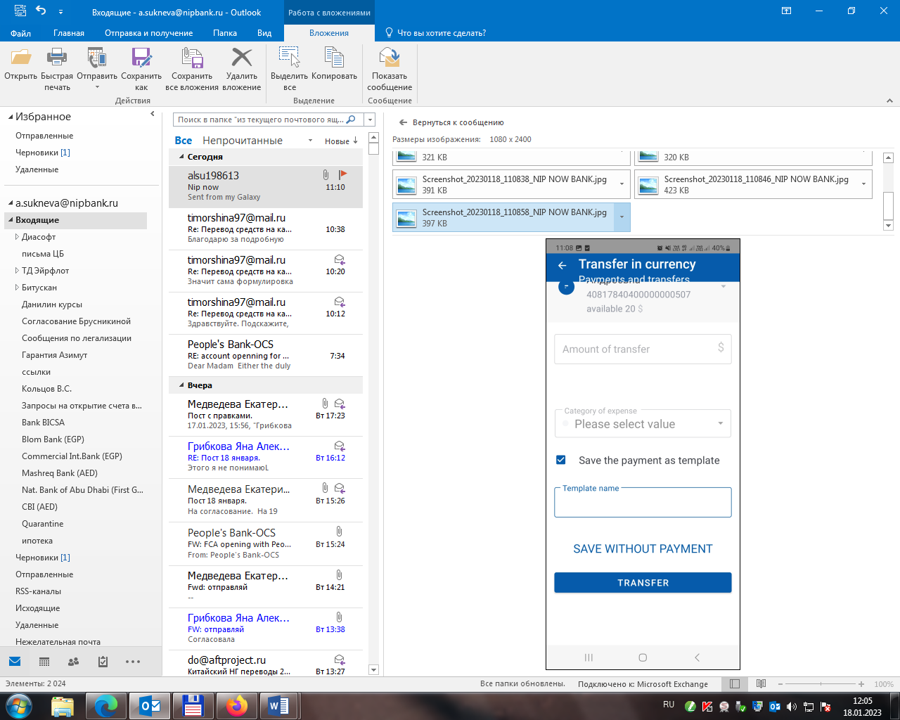

• At the end, you can save the payment as a **template** for future use (Next time you make the transfer, you may use the template and change only the amount of transfer).

1. Press TRANSFER button. You will receive SMS with the confirmation code to make the transfer transaction.

You can make currency exchange operations at any time and day. It will be processed on the same day.

You can make the transfer of funds at any time and day. If the transfer is done in non-working hours or in a non-working day, it will be processed on the next working day.

To make the transfer of funds you should keep the proper amount of funds on your account in USD for commission of the bank. If there is not enough funds for commission on the account, the transfer will not be processed.